### Chapter3 态度与工作满意度

**\*认知失调**

* ***态度总是决定行为吗？利昂·费斯廷格—不是的！***

认知失调： 两个或更多态度之间或者态度与行为之间的任何不一致。

任何形式的不协调都会令人不安，个体会因此试图减少这种不一致，他们将会寻求一种能把失调降到最低程度的稳定状态。

* ***如何自圆其说？***

通过改变态度或行为，或者对失调进行合理化，从而实现一致性。

并不是所有人都需要自圆其说!

* ***减少失调的意愿取决于:（调节因素）***

（1）引发失调的那些因素的重要性

（2）消除失调后个体的影响程度

当人们相信不协调归因于可以控制的事情时，个人将会激发更多动力来减少不协调

（3）失调带来的回报

当高度失调伴随着高度回报时，人们倾向于减少失调中内在的紧张

**\*工作满意度**

* ***定义：正对工作特点进行评估而产生的对工作的积极感觉***

它是一个很广义的定义，员工对自己工作是否满意的评价，常常是个体对许多不同的工作元素进行综合概括的结果。

* ***如何测量工作满意度？***

1. 单一整体评估法（一个问题∕一个回答）

只要求个体回答一个问题，如“如果把所有的因素考虑在内，你对你的工作满意吗

（2）工作要素综合评价法（许多问题∕一个平均分）：

首先需要确定工作中的关键要素，典型的要素包括：工作性质、监督与控制、收入、晋升机会、同事关系

* ***有效性?***

员工是否对自己的工作感到满意？

-收入和晋升是问题最多的方面。

大多数管理者常常高估员工的工作满意度。

* ***工作满意会带来的结果***
* 工作绩效

员工满意度高的组织比员工满意度低的组织更高效

* 组织公民行为

工作满意度会通过公平感来影响组织公民行为

社会交换理论：回报自己的积极体验

* 顾客满意度

对工作感到满意的员工会提高顾客满意度和忠诚度

* 缺勤率

工作满意度和缺勤率之间存在着中等程度的负相关

* 离职率

对工作感到满意的员工离职可能性更低。

在工作满意度—离职率关系中，存在着许多权变因素（就业机会；组织为留住高绩效员工而采取的措施）

* 工作场所中的偏常行为

对工作感到不满的员工更有可能搞小团伙、浪费物品、偷窃以及出工不出力。

* ***员工对工作不满意的应对方式***

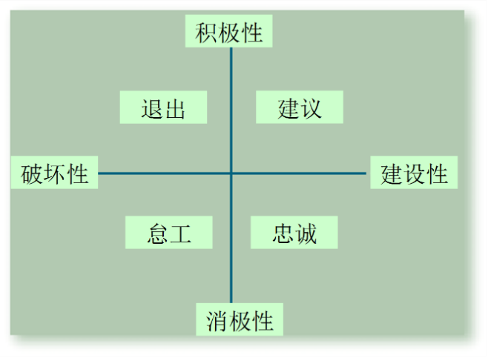

退出：直接离开组织 ，包括寻找新的工作岗位或者辞职

建议：采取主动的、建设性的努力来改善工作条件

忠诚：被动但乐观地等待环境有所改善，包括面对外部批评时站出来为组织说话，以及相信组织及管理层会做出“正确的事”

怠工：被动地听任事态越来越糟，包括长期缺勤或迟到，降低努力程度和增加失误率

* ***哪些因素会引起工作满意***
* 收入在一定程度上影响工作满意度

年收入超过4万美元之后，收入与工作满意度之间不相关。

* 人格也会影响工作满意度

消极的人通常对自己的工作感到不满。

那些具有积极核心自我评价的人通常对自己的工作感到更满意。

个人的满意度通常比较稳定，即使换了雇主和职业。

**\*工作参与**

用于测量一个人从心理上对其工作的认同程度以及认为他的工作绩效水平对自我价值的重要程度。

**\*心理授权**

是指员工认为自己能对工作环境、工作能力、工作意义以及工作自主性产生影响的程度

**\*组织承诺**

在组织承诺中界定了员工对特定组织及其目标的认同，并希望保持组织成员的身份

1. 情感承诺：对组织的情绪依赖以及对组织价值观的认同
2. 持续承诺：与离开组织相比，感受到的留在组织中的经济价值
3. 规范承诺：基于道德及伦理产生的留在组织中的责任感

**\*感知到的组织支持**

指员工相信组织看重他们的贡献并关心他们的福祉程度。员工的组织支持感越强，就更容易产生较高程度的组织公民行为、更低程度的拖拉行为和更好的客户服务

**\*员工敬业度**

主要是指个体对工作的参与度、满意度以及工作的热情

### Chapter4 情绪与心境

**\*情绪劳动**

指员工在工作的人际交往过程中表现出令组织满意的情绪

**\*情绪失调**

指员工需要表现出来的情绪与他的真实情绪不同

会对员工造成重大伤害，把沮丧、愤怒和怨恨封装起来，置之不理，最终会导致情绪衰竭和情绪倦怠。

**\*情绪感受与情绪表达**

在工作方面，把情绪划分为情绪感受和情绪表达。

情绪感受：个体的实际情绪

情绪表达：组织要求员工表现的并被视为符合特定工作的情绪

**\*表层动作与深层动作**

展示伪装的情绪需要压抑我们的真实感情。

* 表层动作：隐藏我们的内在情感，按照表达规则放弃情绪表达。

在自己并不想笑的时候对顾客微笑，就是他的表层动作

* 深层动作：按照表达规则调整内在的真实情感。

保健品供应商努力增加对病人的真正同情

表层动作处理情绪表达，深层动作处理情绪感受。表层动作会让员工更有压力，因为他必须伪装自己的真实情感，所以给从事表层展示的员工放松和恢复的机会非常重要。

**\*情感事件理论AET affective events theory**

* ***情感事件理论证明员工会对工作中发生的事情产生情绪反应，进而这些反应又影响到他们的工作绩效和满意度。***
* 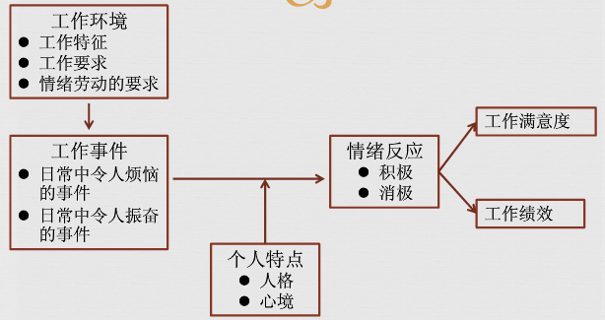

***该理论指出，情绪是对工作环境中的事件的反应。***

1. 情绪片段实际上是单一时间沉淀下来的一系列情绪体验，包括情绪周期和心境周期
2. 当前的情绪影响任何时候的工作满意度，并一直伴随着时间周边的情绪发展
3. 由于心境和情绪随时间而波动，因此它们对绩效的影响也会产生波动
4. 情绪对行为的驱动一般持续时间短，并且可变性很强
5. 因为情绪即使是积极情绪，也会与工作所要求的行为不匹配，所以它们对工作绩效一般具有消积影响

* ***情感事件理论告诉我们的信息***

1. 情绪对于我们理解员工的行为具有重要价值

（2） 员工和管理人员不能忽视情绪及其引发事件，即使它们看上去微不足道，因为会聚少成多

**\*情绪智力 EI emotional intelligence**

* ***情绪智力是一种个人能力，它可以使得个人：***

1. 具有自我意识（当自己体验到情绪时能够识别）
2. 可以察觉他人的情绪
3. 可以管理情绪线索和信息

* ***情绪智力的支持意见***

1. 直觉吸引力
2. 情绪智力可以预测重要的指标
3. 情绪智力有生物基础

* ***情绪智力的反对意见***

1. 情绪智力的概念太模糊
2. 情绪智力无法测量
3. 情绪智力的有效性令人怀疑

### Chapter5 人格与价值观

**\*大五模型 OCEAN**

* ***外倾性（Extraversion）***

描述的是个体对关系的舒适感程度

外倾者：倾向于喜欢群居、善于社交和果断自信

内倾者：倾向于封闭内向、胆小害羞和安静少语

* ***随和性（Agreeableness）***

描述的是个体服从别人的倾向性

高随和性的人：合作的、热情的和信赖他人的

低随和性的人：冷淡的、敌对的和不受欢迎的

* ***责任心（Conscientiousness）***

对可靠性的测量

有高度责任心的人:负责的、有条不紊的、值得信赖的、持之以恒的

得分低的人：很容易精力分散、缺乏规划性，且不可信赖

* ***情绪稳定性（Emotional stability/Neuroticism）***

刻画的是个体承受压力的能力（经常用它的对立面——神经质进行标识）

正向的情绪稳定性者：倾向于是平和的、自信的和安全的

负向的情绪稳定性者：倾向于是紧张的、焦虑的失望的和缺乏安全感的

* ***经验开放性（Openness to experience）***

针对个体对新奇事物的兴趣和热衷程度

开放性非常高的人：富有创造性、凡事好奇、具有艺术的敏感性

开放性比较低的人：很保守、对熟悉的食物感到舒适和满足

* ***大五模型的实证研究结果***
* 责任心几乎与所有职业的工作绩效、OCB成正相关；与寿命成正相关；可能对工作的适应较差；创新水平较低。
* 外倾性与需要人际互动的职业之工作绩效成正相关；更具社交主导性，易成为团队中的领导。
* 经验开放性与外向性可预测几乎所有职业的培训绩效；容易面对模糊性与变革；更有创造性。
* 情绪稳定性与生活满意度、工作满意度成正相关；与压力水平成负相关。
* 随和的人能成为更好的朋友或团队成员，但可能是较差的谈判者。

大五模型中，责任心与工作业绩始终相关度最高，情绪稳定性与工作满意度、生活满意度和低压力相关度最高。

\***内倾与外倾**

* 与内倾的人相比，外倾的人在工作与生活中感受到更幸福。
* 他们比内倾的人体验到更到的积极情感，而且能更自如地表达这些情感，在需要人际互动的工作中也会表现得更好
* 外倾性这一指标能够相对准确地预测谁将成为团队中的领导者
* 外倾者更具有社交主导型，通常比内倾更加自信
* 外倾性的一个消极方面是外倾者往往更加冲动，更有可能撒谎

**影响员工行为的其他人格特征**

核心自我评价 core self-evaluation

马基雅维力主义Machiavellianism

自恋Narcissism

自我监控Self-Monitoring

冒险性Risk-Taking

A型人格Type A Personality

主动性 Proactive Personality

**\*核心自我评价**

* 拥有积极核心自我评价的人喜欢自己，认为自己是有效能和能力的，能够控制周围环境

拥有消极自我评价的人则讨厌自己，质疑自己的能力，认为自己无力控制周围环境

* 核心自我评价与工作满意度相关；与工作绩效成正相关。
* 核心自我评价高的员工有更高的目标，对自己的目标坚持不懈。

**\*自我监控**

* ***是指个体根据外部情景因素调整自己行为的能力***
* ***高自我监督:*** 调整自己的行为以适应变化的环境

适应性强、灵活度高、密切关注他人行动

更易得到晋升机会，但组织忠诚度不高

Putting on different faces for different audiences

* ***低自我监督:*** 不能以这种方式伪装自己，行动受自己的态度、信仰、感觉和原则引导，展示真实性请和态度，不太在意别人对自己行为的看法

展现真我—行为较易预测

**\*冒险性**

* ***高冒险性的管理者***

决策更为迅速、使用的信息量更少

* ***低冒险性的管理者***

决策较慢、使用的信息量更多、决策的准确程度类似

* ***冒险倾向性***

根据工作具体要求考虑与冒险倾向性的匹配性

e.g. stock trader vs. accountant

文化的影响

大型公司的管理人员更容易选择规避风险

**\*A型人格与B型人格**

* ***A型人格***

非常争强好胜，并总是体验到一种时间上的紧迫感，总是不断地驱使自己要在最短的时间里干最多的事，并对阻碍自己工作的其他人或事进行攻击

常常处于高度的焦虑状态，不断给自己施加时间压力，更重视数量而不是质量，很少花时间来研究和开发具体的解决方法因此决策欠佳。他们的行为比B型人更易预测

* ***A型人格表现为：***

1.运动、走路、吃饭通常节奏很快；

2.对很多事情的进展速度感到不耐烦；

3.总是试图同时做两件以上的事情；

4.无法打发休闲时光；

5.着迷于数字，他们的成功是以每件事中自己获益多少来衡量的。

* ***B型人格***

很少受到欲望的折磨，从来不受时间紧迫感的困扰，可以不带无恶感地放松。

* ***B型人格表现为***

1.从来不曾有时间上的紧迫感以及其它类似的不耐烦；

2.认为没有必要表现或讨论自己的成就和业绩，除非环境要求如此；

3.充分享受娱乐和休闲，而不是不惜一切代价实现自己的最佳水平；

4.充分放松而不感内疚。

* A型人在职场面试中做得更好，更可能被评价为具有一些理想特特质，如工作积极性高、能力强、富于进取心和成功动机高。
* ***极端的A型人格容易做到最高层吗？***

健康危机、与他人的冲突、坏的决策

**\*主动型人格**

* ***主动改善现有的环境或者创造新的环境***

发现机会

主观能动性

积极采取行动

持之以恒

* ***更有可能成为领导和组织中的变革推动者***

**\*基本归因错误**

指归因失真的错误或偏见，比如我们在评价他人的行为时，总是倾向于嘀咕外部因素的影响而高估内部或者个人因素的影响。

**\*自我服务偏见**

个体和组织倾向于把成功归因于内部因素（如能力或努力）而把失败归因为外部因素（如运气或同事）

***判断他人时常走的捷径：晕轮效应、对比效应、刻板印象、投射、选择性知觉***

**\*晕轮效应**

当我们以个体的某一特征（如智力、社会活动力、外貌）为基础从而形成对一个人的总体印象时，我们就受到晕轮效应：我们的整体观点影响着我们的某一特定观点。

一个人如果被标明是好（坏）的，他就会被一种积极肯定（否定）的光环笼罩，并被赋予一切都好（坏）的品质。如让奥巴马的批评者列出对他感到佩服的十件事，或让奥巴马的仰慕者列出对他感到厌恶的十件事都很困难。

**\*对比效应**

对比效应可以是直觉失真。我们对一个人的评价并不是孤立进行的，它常常受到我们最近接触到的其他人的影响。

**\*刻板印象**

所在的团体知觉为基础判断某人。

**\*投射**

将自己的特点投射到其他人身上的倾向。

**\*选择性知觉**

据自己的兴趣、背景、经验和态度进行的主动选择。我们对于事物的兴趣显著响到我们对于问题的认识和了解。

**\*绩效期望——皮格玛利翁效应**

员工的绩效评估在很大程度上依赖于知觉过程

* 他人的期望决定个人的行为：自我实现预言
* 赞美、信任和期待具有一种能量，它能改变人的行为
* 要求领导对下属要投入感情、希望和特别的诱导，使下属得以发挥自身的主动性、积极性和创造性。

**常见的偏见和错误**

过分自信偏见 overconfidence bias

锚定偏见 anchoring bias

验证偏见 confirmation bias

易获性偏见 availability bias

承诺升级 escalation of commitment

随机错误 randomness error

风险厌恶 risk aversion

后视偏见 hindsight bias

**\*后视偏见**

当结果已知后，认为先前应该能够进行准确预测。后视偏见降低了我们从过去中学习的能力，它让我们认为自己是很好的预测者并且错误地感到自信。

**\*风险厌恶**

* 偏好确定性而厌恶有风险的结果的倾向
* Gain:偏好获得确定的东西，而不愿冒险
* Loss: 当试图阻止消极结果时，人们宁愿冒险

风险厌恶不完全是负面的。

压力情景可能引起更强烈的风险偏好，对积极的结果，处于压力下的人厌恶风险，对消极的结果，处于压力下的人偏好风险。

**\*承诺升级**

* 人们固守着项决策，尽管有明显证据表明该决策是错误的

——尤其要为该决策的失败负责的时候。当个体感到自己要对失败负责时，就会对这一失败活动增加投入

* 投资决策

管理者常常为了证明自己的决策是正确的，投入大量资源给一开始就注定失败的决策。

**\*过度自信的偏见（最普遍 最具危害性）**

* 过于相信自己制定良好决策的能力

那些智力和人际能力最弱的人最有可能高估自己的绩效和能力，管理人员和雇员的知识越丰富，产生过度自信的可能性就越小，人们越乐观，项目越不成功

* 组织成员在自己专业领域外进行工作时最容易出现过度自信的倾向

**\*锚定偏见**

* 锚定偏见是指把信息固定在初始阶段，一旦固定，我们就无法对接下来的信息作出全面的判断。之所以会有这种偏见，是因为我们的大脑给予最先接收到的信息过多的关注。
* 谈判中的锚定：要有谈判就会有锚定。

**\*验证偏见**

* 仅仅选择和使用那些能够为我们的决策提供支持的信息和事实
* 理性决策过程中假设我们会客观地收集信息，但实际上我们是有选择地收集信息。
* 验证偏见是选择性知觉的一个具体例子。我们寻找能够验证过去的选择性信息，忽视与我们的判断相违背的信息，接受能证实我们先前观点的信息，对那些对我们的观点形成威胁的信息持批评和怀疑态度

**\*易获性偏见**

* 指人们倾向于基于容易获得的信息做出判断。
* 一些事件会唤起人们的情绪，尤其是那些生动鲜明的、最近发生的事情
* 我们更有可能高估那些发生可能性不大的事情，如空难

**\*随机错误**

* 人们倾向于认为自己能够预测随机事件的结果
* 为随机事件赋予意义--迷信。当迷信行为影响日常的判断或者使重要的决策产生偏差时，这种行为的负面效果就显现出来

### Chapter7 Motivation Concepts

**\*****Maslow’ hierarchy of needs马斯洛需要层次理论**

* There is a hierarchy of five needs. As each need is substantially satisfied, the next need becomes dominant.

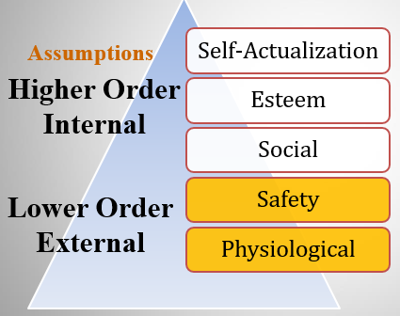

Lower-order needs

Higher-order needs

自我实现需求

尊重需求

社会需求

安全需求

生理需求

* Individuals cannot move to the next higher level until all needs at the current (lower) level are satisfied
* Must move in hierarchical order

**\* McGregor’s theory X(basically negative) and theory Y(positive)**

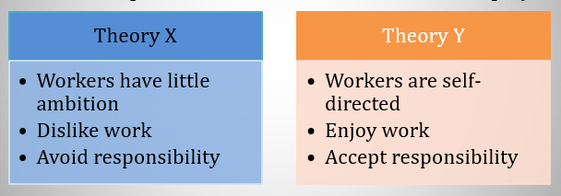

* Managers used a set of assumptions based on their view
* The assumptions molded their behavior toward employees

**\* Herzberg’s two-factor theory赫兹伯格的双因素理论**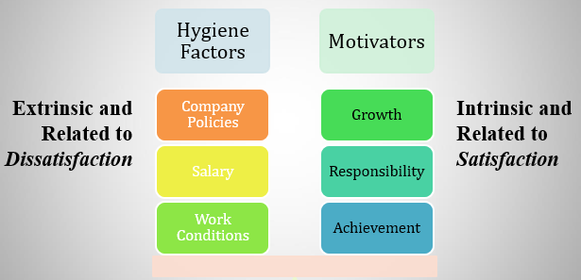

* ***Key Point: Satisfaction and dissatisfaction are not opposites but separate constructs***
* Herzberg says that hygiene factors must be met to remove dissatisfaction. If motivators are given, then satisfaction can occur.
* Herzberg is limited by his methodology （方法论）

Participants had self-serving bias

* Reliability of raters questioned

Bias or errors of observation

* No overall measure of satisfaction was used
* Herzberg assumed, but didn’t research, a strong relationship between satisfaction and productivity

**\* McClelland’s theory of needs麦克莱兰的需求理论**

* ***Need for Achievement (nAch)成就需求***

The drive to excel, to achieve in relation to a set of standards, to strive to succeed

* ***Need for Power (nPow)权利需求***

The need to make others behave in a way that they would not have behaved otherwise

* ***Need for Affiliation (nAff)归属需求***

The desire for friendly and close interpersonal relationships

* People have varying levels of each of the three needs.

Hard to measure

* ***People with a high need for achievement are likely to:***

1. Prefer to undertake activities with a 50/50 chance of success, avoiding very low- or high-risk situations
2. Be motivated in jobs that offer high degree of personal responsibility, feedback, and moderate risk
3. Not necessarily make good managers – too personal a focus. Most good general managers do NOT have a high nAch
4. Need high level of nPow and low nAff for managerial success

* ***Good research support, but it is not a very practical theory***

**\* Self-determination theory自我决定理论**

* People prefer to feel they have control over their actions, so anything that makes a previously enjoyed task feel more like an obligation than a freely chosen activity will undermine motivation.
* ***Major Implications for Work Rewards***

1. Intrinsic and extrinsic rewards are not independent
2. Extrinsic rewards may decrease intrinsic rewards
3. Goal setting is more effective in improving motivation
4. Verbal rewards increase intrinsic motivation; tangible rewards reduce it

**\* Goal-setting theory目标设置理论**

* ***Basic Premise: 基本前提***

That specific and difficult goals, with self-generated feedback, lead to higher performance

* ***Difficult Goals:***

1. Focus and direct attention
2. Energize（激励） the person to work harder
3. Difficulty increases persistence
4. Force people to be more effective and efficient

* ***Relationship between goals and performance depends on:***

1. Goal commitment (the more public the better!)目标承诺
2. Task characteristics (simple, well-learned)任务特点
3. Culture (best match is in North America)民族文化

**\*Implementation: Management by Objectives目标管理**

* ***MBO is a systematic way to utilize goal-setting.利用目标设置***
* ***Goals must be:***

1. Tangible明确的
2. Verifiable可检验的
3. Measurable可测量的

* ***Corporate goals（公司目标） are broken down into smaller, more specific goals at each level of organization.***
* ***Four common ingredients to MBO programs:四种要素***

1. Goal specificity目标的具体性
2. Participative decision making参与决策
3. Explicit time period明确的时间期限
4. Performance feedback绩效反馈

**\*Bandura’s self-efficacy theory自我效能理论**

* An individual’s belief that he or she is capable of performing a task.

1. ***Higher efficacy is related to:***

Greater confidence

Greater persistence in the face of difficulties

Better response to negative feedback (work harder)

1. ***Self-efficacy complements Goal-Setting Theory***

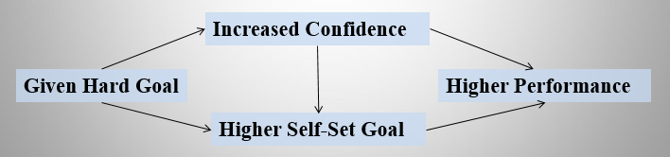

自我效能

自我设置

任务绩效

任务目标

* ***Enactive mastery过去的成功经验***

1. Most important source of efficacy（功效）
2. Gaining relevant experience with task or job
3. “Practice makes perfect”

* ***Vicarious modeling替代榜样***

1. Increasing confidence by watching others perform the task
2. Most effective when observer sees the model to be similar to him- or herself

* ***Verbal persuasion口头说服***

1. Motivation through verbal conviction
2. Pygmalion and Galatea effects - self-fulfilling prophecies

* ***Arousal唤醒***

1. Getting “psyched up”（精神上准备好） – emotionally aroused – to complete task
2. Can hurt performance if emotion is not a component of the task

**\* Reinforcement theory强化理论**

* ***Similar to Goal-Setting Theory, but focused on a behavioral approach(行为主义观点)rather than a cognitive one（认知观点）***
* Behavior is environmentally caused
* Thought (internal cognitive event) is not important

Feelings, attitudes, and expectations are ignored

* Behavior is controlled by its consequences – reinforcers
* Is not a motivational theory but a means of analysis of behavior
* Reinforcement strongly influences behavior but is not likely to be the sole cause

**\* Operant conditioning theory**

**\*** **Adam’s Equity theory**

* ***Employees compare their ratios of outcomes-to-inputs of relevant others.***
* When ratios are equal: state of equity exists – there is no tension as the situation is considered fair
* When ratios are unequal: tension exists due to unfairness

Underrewarded states cause anger

Overrewarded states cause guilt

* Tension motivates people to act to bring their situation into equity
* ***Can be four different situations:四种参照比较***

1. **Self-Inside自我-内部**

The person’s experience in a different job in the same organization

1. **Self-Outside自我-外部**

The person’s experience in a different job in a different organization

1. **Other-Inside他人-内部**

Another individual or group within the organization

1. **Other-Outside他人-外部**

Another individual or group outside of the organization

* ***Employee behaviors to create equity:***
* Change inputs (slack off)改变自己的投入
* Change outcomes (increase output)改变自己的产出
* Distort/change perceptions of self歪曲对自我的认识
* Distort/change perceptions of others歪曲对他人的认识
* Choose a different referent person选择其他参照对象
* Leave the field (quit the job)离开
* ***Propositions relating to inequitable pay:***
* **Paid by time:**

Overrewarded employees produce more

Underrewarded employees produce less with low quality

* **Paid by quality:**

Overrewarded employees give higher quality

Underrewarded employees make more of low quality

**\*the concepts of justice**

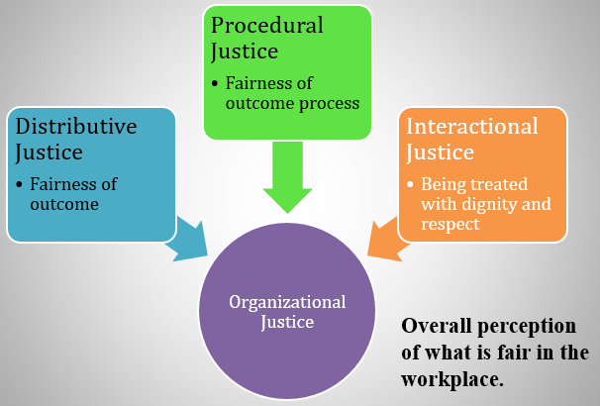

分配公平：对结果公平的感知

程序公平：对结果的判定过程的公平性的感知

互动公平：个体对尊严及尊敬的感知程度

组织公平：对工作场所的整体感知

**\*** **Vroom’s expectancy theory期望理论**

* The strength of a tendency to act in a certain way depends on the strength of an expectation that the act will be followed by a given outcome and on the attractiveness（吸引力） of the outcome to the individual.

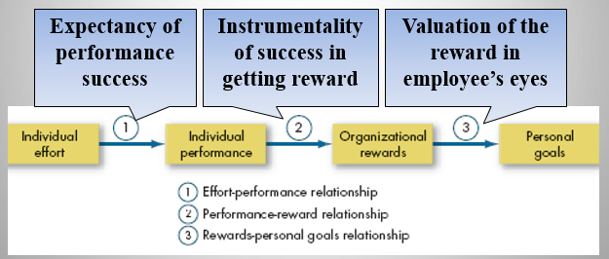

1. 努力-绩效关系
2. 绩效-奖励关系
3. 奖励-个人目标关系

### Chapter8 Motivation: From Concepts to Applications

**\*Job characteristics model工作特征模型**

* ***Five Core Job Dimensions五个核心工作维度***

1. **Skill Variety:技能多样性**

degree to which the job incorporates a number of different skills and talents

1. **Task Identity: 任务完整性**

degree to which the job requires the completion of a whole and identifiable piece of work

1. **Task Significance: 任务重要性**

how the job impacts the lives of others

1. **Autonomy: 工作自主性**

identifies how much freedom and independence the worker has over the job

1. **Feedback: 反馈**

how much the job generates direct and clear information about the worker’s performance

### Chapter9 Foundations of Group Behavior

**\* Group Development Stages群体发展的阶段-五阶段模型**

1. **Forming stage 形成阶段**

Members feel much uncertainty不确定性

1. **Storming stage 震荡阶段**

Lots of conflict between members of the group 内部冲突

1. **Norming stage 规范阶段**

Members have developed close relationships and cohesiveness（群内关系和内聚力）

1. **Performing stage 执行阶段**

The group is finally fully functional

1. **Adjourning stage 解体阶段**

In temporary groups, characterized by concern with wrapping up activities(善后工作)rather than performance

**\* Punctuated-Equilibrium Model间断-平衡模型：用来描述具有明确截止日期的临时群体**

Temporary groups under time constrained deadlines go through transitions between inertia and activity（不活动和活动）---at the half-way point, they experience an increase in productivity.

**\* Mid-point transition**

* ***The transition occurs at exactly the half-way point in time toward the group’s deadline.***
* An apparent need to move forward.
* Seeking outside advice.
* Consolidating acquired information 巩固得到的信息
* Taking a completely new approach.
* Crystallizing the group’s activities.具体化组织的活动

**\* Group properties1:group roles角色**

* ***Task Roles***

Roles performed by group members to ensure that the tasks of the group are accomplished

* ***Maintenance Roles***

Roles performed by group members to maintain good relations within the group

**\* Group Property 2: Norms规范**

* ***Acceptable standards of behavior within a group that are shared by the group’s members群体成员共同接受的一些行为标准***
* Regulate individual behavior
* Make behavior predictable
* When aligned with company goals, usually lead to effective group performance
* ***The Hawthorne Studies霍桑实验***
* Worker behavior and sentiments were closely related.
* Group influences (norms) were significant in affecting individual behavior.
* Group standards (norms) were highly effective in establishing individual worker output.
* Money was less a factor in determining worker output than were group standards, sentiments, and security.
* ***Conformity to Norms从众***
* **Conformity**

Gaining acceptance by adjusting one’s behavior to align with（匹配） the norms of the group

* **Reference Groups参照群体**

Important groups to which individuals belong or hope to belong and with whose norms individuals are likely to conform.

* **Defying Norms: Deviant Workplace Behavior工作场所中的偏常行为**
* Also called antisocial behavior or workplace incivility

不当行为或工作场所中的无礼行为

* Voluntary behavior that violates(违反)significant organizational norms and, in doing so, threatens the well-being of the organization违反重要组织规则从而威胁组织或其他成员的利益

**\*** **Group Property 3: Status地位**

* ***A socially defined position or rank（位置或层级）given to groups or group members by others – it differentiates（区分） group members***
* Important factor in understanding behavior
* Significant motivator重要的激励因素
* ***Status Characteristics Theory***

Status derived from one of three sources:

* Power a person has over others驾驭他人的权利
* Ability to contribute to group goals对群体目标做出贡献的能力
* Personal characteristics个人特征
* ***Status Effects***
* **On Norms and Conformity地位与规范**

High-status members are less restrained（约束） by norms and pressure to conform

Some level of deviance(异常)is allowed to high-status members so long as it doesn’t affect group goal achievement

* **On Group Interaction地位和群体互动**

High-status members are more assertive（果断的）

Large status differences limit diversity of ideas and creativity

* **On Equity地位的不公平**

If status is perceived to be inequitable, it will result in various forms of corrective behavior.采取各种各样的措施来纠正这种失衡

**\* Group Property 4: Size规模**

* Groups with an odd number of members preferable (to avoid ties)
* Groups of between 5 and 9 tend to combine the best elements of small and large groups
* **Social Loafing社会惰化**
* ***The tendency for individuals to expend less effort when working collectively than when working individually***

1. Ringelmann’s Rope Pull（瑞歌尔曼的拔河研究）: greater levels of productivity but with diminishing（减少的） returns as group size increases
2. Caused by either equity concerns or a diffusion of responsibility（责任分散） (free riders)（搭便车者）

* ***Prevent social loafing by:***

1. Setting group goals设立群体目标
2. Increase intergroup competition增强群体竞争
3. Use peer evaluation开展同事评估
4. Distribute group rewards based on individual effort挑选积极性高的成员

**\* Group Property 5: Cohesiveness内聚力**

* ***Degree to which group members are attracted to each other and are motivated to stay in the group。成员之间相互吸引以及愿意留在该群体中的程度。***
* ***To increase cohesiveness:***

1. Make the group smaller.
2. Encourage agreement with group goals.鼓励对群体目标的认同
3. Increase time members spend together.增加群体成员在一起的时间
4. Increase group status and admission difficulty.提高群体的地位和承认困难
5. Stimulate competition with other groups.激励与其他群体的竞争
6. Give rewards to the group, not individuals.奖励群体而不是个体
7. Physically isolate the group.使该群体拥有单独的物理空间

**\*Group Cohesiveness, Norms, and Productivity**

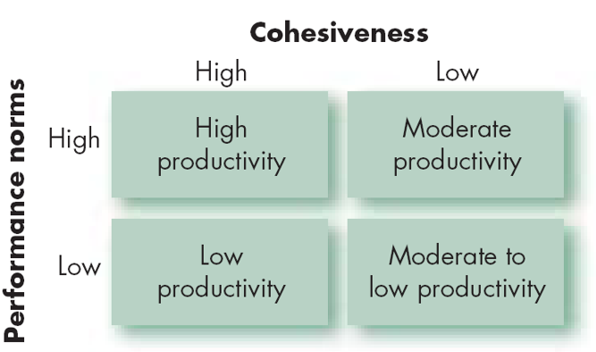

**\*** **Group Diversity**

* Diversity – the degree to which members of the group are similar to, or different from, one another.
* Increases group conflict especially in the short term.
* Culturally and demographically diverse groups may perform better over time.

Over time, diversity may help them be more open-minded and creative.

* Faultlines

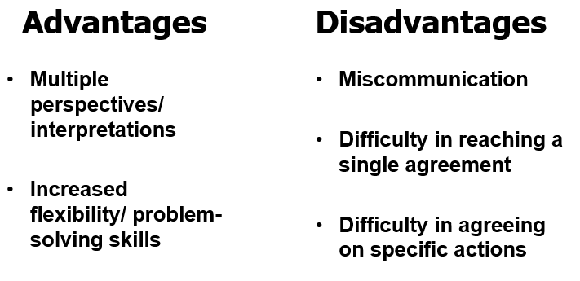

**\* Groupthink群体思维**

* ***Phenomenon in which the norm for consensus overrides the realistic appraisal of alternative courses of action***
* ***Situations where group pressures for conformity deter the group from critically appraising unusual, minority, or unpopular views群体中的从中压力使得该群体难以批判性地评估那些不同寻常的、自少数派提出的或者不受欢迎的观点***
* ***Minimize Groupthink by:***

1. Reduce the size of the group to 10 or less监控群体规模
2. Encourage group leaders to be impartial鼓励群体的领导者扮演公正无偏的角色
3. Appoint a “devil’s advocate”任命一个“吹毛求疵者”（提出质疑或不同观点）
4. Use exercises on diversity使用各种练习

**\*Groupshift群体偏移**

* ***When discussing a given set of alternatives and arriving at a solution, group members tend to exaggerate the initial positions that they hold. 群体讨论使群体成员最初持有的立场迈向更极端的方向***
* ***Resulting in a shift to more conservative or more risky behavior.向更保守或更冒险转变***
* ***What Causes Groupshift?***

1. Familiarization among group members群体成员间的熟悉
2. Biased information sampling 有偏见的信息抽样
3. Group diffuses responsibility (higher risk-taking tendency)责任分散

**群体决策技术：互动群体、头脑风暴、名义小组技术、电子会议**

**\* Interacting groups互动群体**

* ***Most group decision making takes place in interacting groups.*** 
  + Members meet face-to-face and rely on both verbal and nonverbal interaction to communicate with each other.面对面交流，依赖言语和非言语互动来沟通
* ***Interacting groups often censor themselves and pressure individual members toward conformity of opinion.互动群体往往为了使成员达成一致意见对成员施加压力***

**\*** **Brainstorming头脑风暴**

* ***Brainstorming can overcome pressures for conformity. 抑制从众压力***
* ***In a brainstorming session（会议）:***

1. The group leader states the problem clearly领导者清楚地讲明问题.
2. Members then “free-wheel” as many alternatives as they can.
3. No criticism is allowed.不得提出批评意见
4. One idea stimulates others, and group members are encouraged to “think the unusual.”

**\* Nominal group technique 名义小组会议**

* ***The nominal group technique - restricts discussion or interpersonal communication during the decision making process.在决策过程中对群体成员的讨论或人际沟通进行了限定***

1. Group members are all physically present, but members operate independently.都要出席会议，但首先进行单独决策
2. The main advantage is that it permits the group to meet formally but does not restrict independent thinking, as does the interacting group. 让群体成员正式参加会议，但又不像互动群体那样限制个人的独立思维

* ***Research shows that nominal groups outperform（胜过） brainstorming groups.***
* ***In a nominal group, a problem is presented, then…***
  1. Each member independently writes down his/her ideas on the problem.
  2. After this silent period, each member presents one idea to the group. 沉默阶段之后，每个成员想群体提交自己的一个创意
  3. The ideas are discussed for clarity.进行阐述
  4. Each group member rank-orders the ideas. 每个成员评估创意
  5. The idea with the highest aggregate ranking determines the final decision. 合计排名最高的创意将成为最终方案

**\*** **Electronic meeting 电子会议**

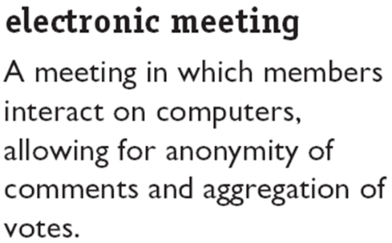

### Chapter10 Understanding Work Teams

**\* Types of Work Teams**

* ***Problem-Solving Teams问题解决团队***
  + Employees from the same department who discuss ways of improving quality, efficiency, and the work environment
* ***Self-Managed Teams自我管理型团队***
  + The team takes on responsibilities of their former supervisors 承担了很多以前由他们的主管承担的职责
* ***Cross-Functional Teams跨职能团队***
  + Employees from about the same hierarchical level, but from different work areas work for a project组织层级相近但来自不同工作领域的员工
* ***Virtual Teams虚拟团队***
  + Physically dispersed members are connected by the use of computer technology 利用电脑技术把分散在不通过地方的成员联系起来

### Chapter12 Leadership

**\*Trait Theories of Leadership领导特质理论**

* ***Theories that consider personality, social, physical, or intellectual traits to differentiate leaders from non-leaders.***
* ***Not very useful until matched with the Big Five Personality Framework.***
* ***Traits can predict leadership, but they are better at predicting leader emergence than effectiveness.***
* ***The trait approach does have something to offer.***
* ***Good leaders:***
  1. Like being around people.
  2. Are able to assert themselves (extraverted).
  3. Are disciplined and able to keep commitments they make (conscientious).
  4. Are creative and flexible (open).

**\*** **Behavioral Theories of Leadership行为理论**

* ***Theories proposing that specific behaviors differentiate leaders from nonleaders***
* ***Differences between theories of leadership:***
  + Trait theory特质理论: leadership is inherent, so we must identify the leader based on his or her traits
  + Behavioral theory行为理论: leadership is a skill set and can be taught to anyone, so we must identify the proper behaviors to teach potential leaders

**\*Behavioral Approach**

* ***Ohio State Studies/U. of Michigan***
  + Initiating Structure/Production Orientation
  + Consideration/Employee Orientation
  + *Assumption: Leaders can be trained*
* ***Goal: Develop leaders***
* ***Problem: Effective behaviors do not generalize across situations***

**\*** **Contingency Theories权变理论**

* ***While trait and behavior theories do help us understand leadership, an important component is missing: the environment in which the leader exists***
* ***Contingency Theory adds this additional aspect to our understanding leadership effectiveness studies***
  + Fiedler’s Model
  + Hersey and Blanchard’s Situational Leadership Theory
  + House’s Path-Goal Theory

**\* Fiedler’s Model费德勒模型**

* ***Leader: Style is Fixed (Task oriented vs. Relationship oriented)***

***任务导向或关系导向***

* ***Considers Situational Favorableness for Leader三种权变或情境维度***
  + Leader-member relationsis 领导者-成员关系
  + Task structure任务结构
  + Position power职位权利

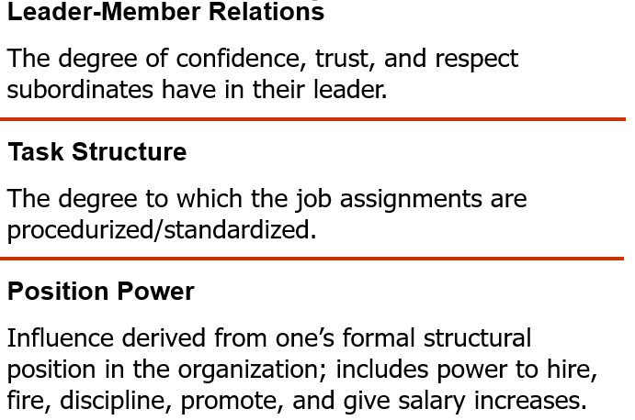

* ***Key Assumption关键假设：领导者与情境的匹配***
  + - Leader must fit situation; options to accomplish this: 替换领导者以适应情境
    - Select leader to fit situation选择适合情境的领导
    - Change situation to fit leader改变情境以适应领导者

**\*** **Hersey & Blanchard Situational Leadership Theory赫塞和布兰查德的情境领导理论**

* ***Considers Leader Behaviors (Task & Relationship)*** 
  + Assumes Leaders CAN change their behaviors
* ***Considers Followers as the Situation***
  + Follower Task maturity (ability & experience)
  + Follower Psychological maturity (willingness to take responsibility)
* ***Assumptions***
* Leaders can and should change their style to fit their followers’ degree of readiness (willingness and ability)
* Therefore, it is possible to TRAIN leaders to better fit their style to their followers.
* ***A model that focuses on follower “readiness”***

- Followers can accept or reject the leader

- Effectiveness depends on the followers’ response to the leader’s actions

- “Readiness” is the extent to which people have the ability and willingness to accomplish a specific task

z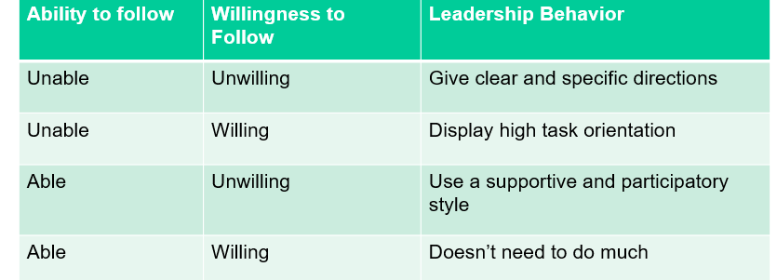

**\* House’s Path-Goal Theory 路径-目标理论理论**

* ***Builds from the Ohio State studies and the expectancy theory of motivation***
* ***The Theory:*** 
  + Leaders provide followers with information, support, and resources to help them achieve their goals为下属提供信息、支持或其他必要的资源来帮助他们实现他们的目标是领导者的工作
  + Leaders help clarify the “path” to the worker’s goals
  + Leaders can display multiple leadership types
* ***Four types of leaders:***
  + Directive: focuses on the work to be done命令型领导
  + Supportive: focuses on the well-being of the worker支持型领导
  + Participative: consults with employees in decision making参与型领导
  + Achievement-Oriented: sets challenging goals

**\* Leader–Member Exchange Theory领导者-成员交换理论**

* Because of time pressures, leaders form a special relationship with a small group of followers: the “in-group”由于时间压力，领导者与下属中的少部分人建立了特殊关系，这些个体成为“圈内人”
* This in-group is trusted and gets more time and attention from the leader (more “exchanges”)他们受到信任，得到领导者更多关照，更有可能享有特权
* All other followers are in the “out-group” and get less of the leader’s attention and tend to have formal relationships with the leader (fewer “exchanges”)

***RESULT: “In” subordinates will have higher performance ratings, less turnover, and greater job satisfaction更好的工作绩效，更少的逆转和更高的工作满意度***



**\*** **Charismatic Leadership魅力型领导**

* ***House’s Charismatic Leadership Theory:***
  1. Followers make attributions of heroic or extraordinary leadership abilities when they observe certain behaviors下属观察到某些特定的行为时，会把它们归因于英雄主义的或者超乎寻常的领导能力
  + ***Four characteristics of charismatic leaders:***
  + Have a vision有一个愿景
  + Are willing to take personal risks to achieve the vision愿意为实现愿景而承担个人风险
  + Are sensitive to follower needs对下属的需求十分敏感
  + Exhibit behaviors that are out of the ordinary展现出超乎常规的行为
  + ***Traits and personality are related to charisma***
* ***People can be trained to exhibit charismatic behaviors人们可以被训练成为魅力型领导者***
* **How** **Charismatic Leaders Influence Followers如何影响下属**
* ***A four-step process:四个步骤***
  1. Leader articulates an attractive vision阐述一个有吸引力的愿景
     + Vision Statement: A formal, long-term strategy to attain goals
     + Links past, present, and future
  2. Leader communicates high performance expectations and confidence in follower 向下属传达高绩效期望
  3. Leader conveys a new set of values by setting an example通过自己的言语和行为向下属传递一套新的价值观
  4. Leader engages in emotion-inducing and often unconventional behavior to demonstrate convictions about the vision领导者常常会采取能够激发情感的、常常是非传统的行为来表明他们的勇气和对愿景的坚定信念
* ***Are Charismatic Leaders Born or Made?***
  1. Some individuals are born with charismatic traits, others are trained to exhibit charismatic behaviors.
     + Develop the aura of charisma by maintaining an optimistic view, using passion as a catalyst for generating enthusiasm, and communicating with the whole body, not just with words. 产生魅力光环：使用激情作为激发他人热情的催化剂；运用整个身体而不只是语言进行沟通
     + Create a bond that inspires others to follow. 创建鼓舞他人追随自己的纽带
     + Bring out the potential in followers by tapping into their emotions. 个体通过调动跟随者的情绪来激发他们的潜能
* **Charismatic Leadership Issues**
* ***Importance of vision愿景的重要性***

Must be inspirational, value-centered, realizable, and given with superior imagery and articulation

* ***Charisma works best when:***
  + - The follower’s task has an ideological component下属的任务中包含很多意识形态成分时
    - There is a lot of stress and uncertainty in the environment当环境带来很大的压力与不确定性时
    - The leader is at the upper level of the organization领导者属于组织中的较高层次
    - Followers have low self-esteem and self-worth缺乏自尊并且质疑自我价值
* ***Dark Side of Charisma魅力型领导的缺点***

Ego-driven charismas allow their self-interest and personal goals to override the organization’s goals让个人利益和目标凌驾于组织目标之上

**\*Transactional & Transformational Leadership交易型领导与变革型领导**

* ***Transactional Leaders交易型领导***
  + Leaders who guide or motivate their followers in the direction of established goals by clarifying role and task requirements通过澄清工作角色与任务要求来指导下属完成既定目标
* ***Transformational Leaders变革型领导***
  + Inspire followers to transcend their own self-interests for the good of the organization; they can have a profound and extraordinary effect on followers鼓舞下属将个体利益升华为组织利益，并对下属产生超乎寻常的深远影响
* ***Not opposing, but complementary, approaches to leadership不是截然对立，而是互为补充***
  + Great transformational leaders must also be transactional; only one type is not enough for success好的变革型领导必然也是交易型的
* **Characteristics of TAL & TFL特征**

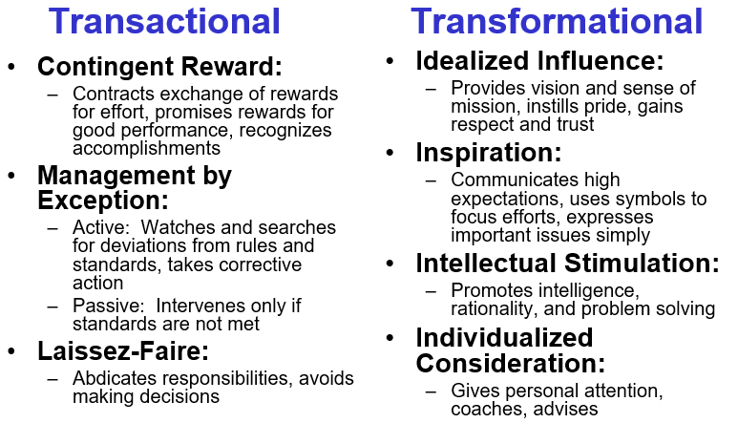

**权变式奖励：制定努力与奖励的交换 领袖魅力：提供愿景和使命感，灌输**

**规则，承诺对良好绩效 荣誉感，赢得尊重和信任**

**给予奖励，认可成就 感染力：传达高期望，用各种方式实**

**例外管理；主动的：观察并寻找那些 现众志成城，以简单的方式**

**偏离规则和标准的行为 来传达重要目的**

**和事件并予以纠正 智力刺激：促进人们的智力和理性，**

**被动的：只有当不符合标 并培养员工解决问题的能力**

**准时才实施干预 个性化关怀：关爱员工，区别对待不同**

**放任型：放弃责任，避免制定决策 员工，提供指导和建议**

**\*** **Authentic Leadership: Ethics and Trust诚信领导：道德和信任**

* ***Authentic Leaders:诚信领导***
  + Ethical people who know who they are, know what they believe in and value, and act on those values and beliefs openly and candidly清楚地知道自己是谁，知道自己的信念和价值观，能够坦率、公开地按照自己的信念和价值观行事
  + Primary quality is trust主要品质就是信任
* ***Build trust by:***
  + Sharing information信息分享
  + Encouraging open communication
  + Sticking to their ideals

**\* Attribution Theory of Leadership领导归因理论**

* + ***The idea that leadership is merely an attribution that people make about other individuals领导仅仅是人们对其他个体进行的一种归因***
  + ***Qualities attributed to leaders:对领导的归因***
    - Leaders are intelligent, outgoing, have strong verbal skills, are aggressive, understanding, and industrious.领导是拥有高智商、开朗的性格、很强的语言表达能力、进取心、理解力且勤奋的人
    - Effective leaders are perceived as consistent and unwavering in their decisions.对他们的决定更坚持、更坚定不移
    - Effective leaders project the appearance of being leaders.展示出有效领导者的外在形象

**\*** **Neutralizers & Substitutes for Leadership领导的替代因素和抵消因素**

* ***Neutralizers抵消因素***
  + Factors in the work setting that reduce a leader’s opportunity to exercise influence.
* ***Substitutes替代因素***
  + Factors in the work setting that can take the place of active leadership making it unnecessary or redundant.（P341）

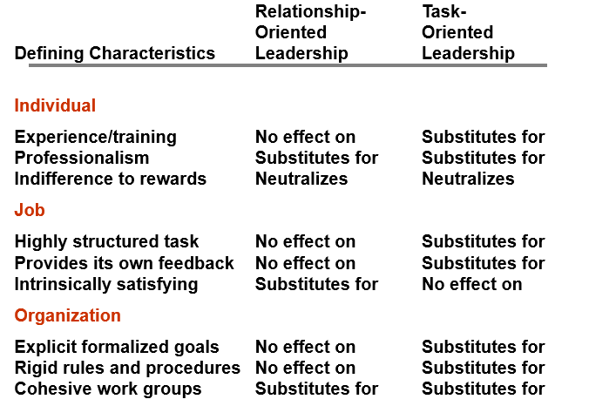

### Chapter13 Power and Politics

**\*Five types of power**

**正式权力**

* Coercive Power强制权力：依赖于人们对不服从命令会导致的消极结果的惧怕
* Reward Power奖赏权力：某个人能够给人们带来他们认为有价值的奖赏
* Legitimate Power法定权力：代表组织成员根据自己在组织结构中的职位来控制和使用 组织资源的正式职权

**个人权利**

* Expert Power专家权利：专长、特殊职能或知识产生的影响
* Referent Power参照权利：人们认同某个拥有令人羡慕的资源或个人特质的人

**\*Nine power tactics九种权术**

* Legitimacy合法性：核算你的职权或者强调你的要求符合组织的规章制度
* Rational persuasion理性说服：提出符合逻辑的观点和事实依据证明某个请求的合理性
* Inspirational appeals鼓舞式诉求：通过呼吁某个目标的价值观、需求、希望和渴望来引起情感认同
* Consultation 商议：通过让他人参与决定你将如何实施你的计划来增加他人对你的支持
* Exchange 交换：通过给他人提供某些利益或好处来换取其对某项要求的遵循
* Personal appeals 个人式诉求：利用友谊或忠诚来获取他人的同意
* Ingratiation 逢迎：在提出请求之前先采取吹捧、赞扬或友善行为
* Pressure 施压：使用警告、威胁和反复要求等手段
* Coalitions 联盟：通过寻求他人的帮助或支持来说服目标对象同意